# Exercises: HTML and CSS Overview

Problems for exercises and homework for the ["HTML and CSS" course @ SoftUni](https://softuni.bg/courses/web-fundamentals-html5). Submit your solutions in the SoftUni judge system at <https://judge.softuni.bg/Contests/394/HTML-and-CSS-Overview> .

## My First Page

Create a Web Page like the following.

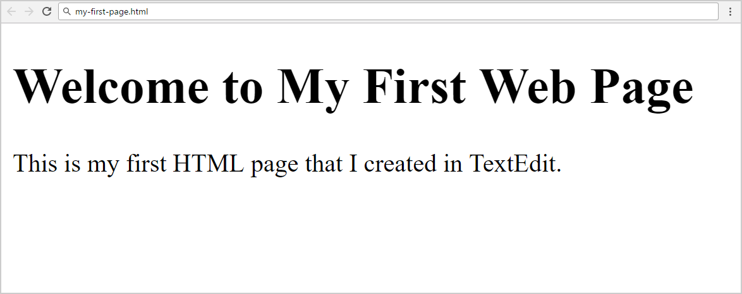

Create “**my-first-page.html**”

### Constraints

* <h1> tag for heading
* <p>tag for paragraph

## Definition Lists

Create a Web Page like the following.

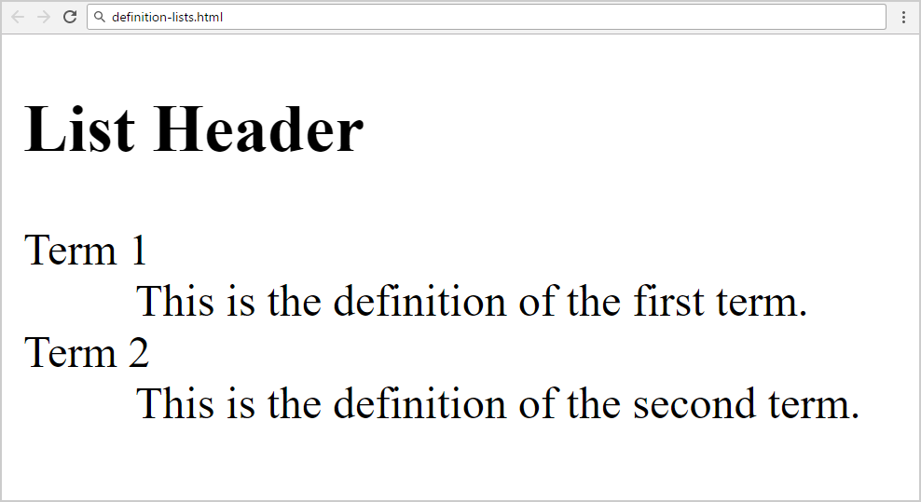

Create “**definition-lists.html**”

### Constraints

* <h2> tag for heading
* <dl>tag for definition list

<h1>List Header</h1>

<dl>

<dt>Term 1</dt>

<dd>This is the definition of the first term.</dd>

<dt>Term 2</dt>

<dd>This is the definition of the second term.</dd>

</dl>

## Reversed List

Create a Web Page like the following.

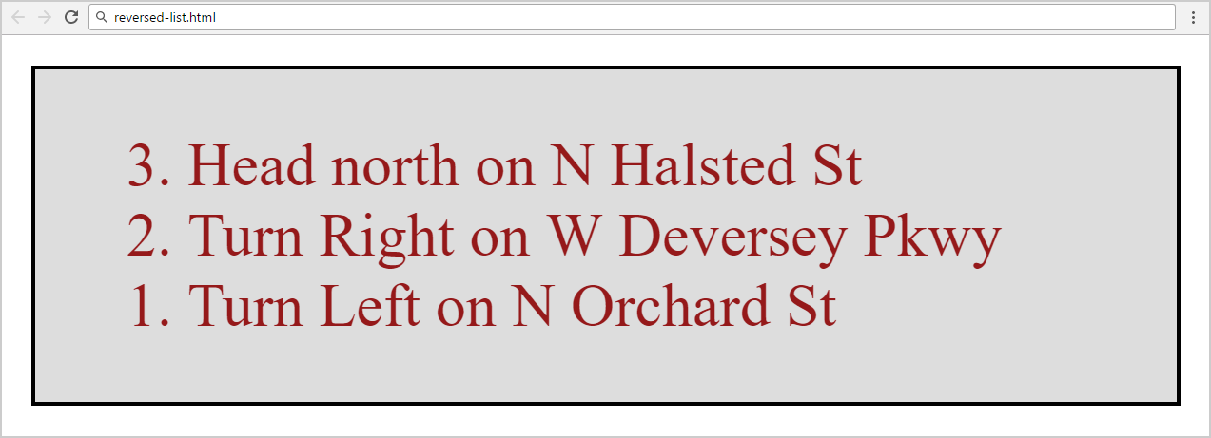

Create two files: “**reversed-list.html**”and“**reversed-list.css**”

### Constraints

* <div>with **id=wrapper** as a **container**
  + Background color: #dddddd;
  + Text color: #95191a;
  + Width container: 300px;
  + Border: 1px solid #000000;

### Hints

Use:

* <ol> with **reversed** attribute
  + <ol reversed="reversed">
* Submit **only** **reversed-list.html** + **reversed-list.css** in **ZIP** file
* <div id="wrapper">
* <ol reversed>
* <li>Head north on N Halsted St</li>
* <li>Turn Right on W Deversey Pkwy</li>
* <li>Turn Left on N Orchard St</li>
* </ol>
* </div>

## The Runners Home

Create a Web Page like the following using **Runners-Home.txt**.

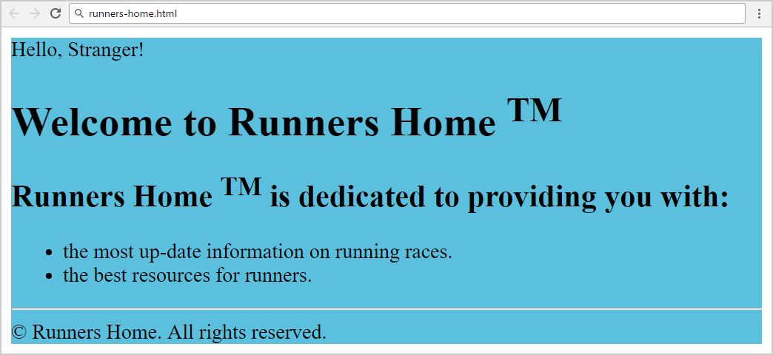

Create two files: “**runners-home.html**” and “**runners-home.css**”

### Constraints

* **<div>** with **id=wrapper** as a **container**
  + Background color: **#5bc0de;**

**Hints**

Use:

* <h1> and <h2>tags for headings
* <sup>tag for **superscript text**
* <p> tag for paragraphs and <span> for Hello, Stranger!
* <ul>tag for list items
* <hr />for horizontal line
* <footer>tag for copyright part + **&copy;** for copy right symbol
* <div id="wrapper">
* <p>Hello, Stranger!</p>
* <h1>Welcome to Runners Home <sup>TM</sup></h1>
* <h2>Runners Home <sup>TM</sup> is dedicated to providing you with:</h2>
* <ul>
* <li>the most up-date information on running races.</li>
* <li>the best resourses for runners.</li>
* </ul>
* <hr>
* <footer>&copy Runners Home. All rights reserved.</footer>
* </div>

## Book Story

* Create a Web Page like the following using **Book-Story.txt**.

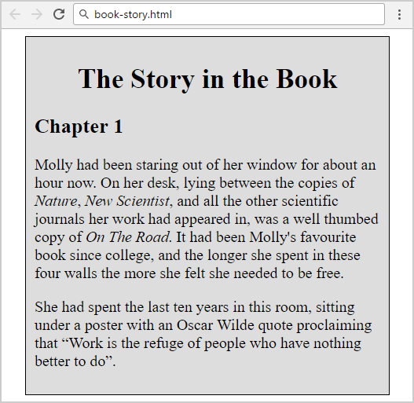

Create two files: “**book-story.html**”and“**book-story.css**”

### Constraints

* **<div>** with **id=wrapper** as a **container**
  + Width container: **400px;**
  + Background color: **#dddddd;**
  + Border: **1px solid #000000;**
  + Margin Left**: 20px;**
  + Padding**: 10px;**
* **<p>** tag for paragraph + **font-size: 18px;**
* **<em>** tag for italic text

### Hints

Use:

* **<h1>** tagfor heading + **center the text**
* **<q>** tag for quotation text
  + **q::before {  
     content: open-quote;  
    }**
  + **q::after {   
     content: close-quote;  
    }**
* <div id="wrapper">
* <h1>The Story in the Book</h1>
* <h2>Chapter 1</h2>
* <p>Molly had been staring out of her window for about an hour now. On her desk, lying between the copies of <em>Nature, New Scientist,</em> and all the other scientific journals her work had appeared in, was a well thumbed copy of <em>On The Road.</em> It had been Molly's favourite book since college, and the longer she spent in these four walls the more she felt she needed to be free.</p>
* <p>She had spent the last ten years in this room, sitting under a poster with an Oscar Wilde quote proclaiming that <q>Work is the refuge of people who have nothing better to do</q>.</p>
* </div>

**Css**

**#wrapper{**

**width: 400px;**

**background-color: #dddddd;**

**border: 1px solid #000000;**

**margin-left: 20px;**

**padding: 10px;**

**}**

**p{**

**font-size: 18px;**

**}**

**h1{**

**text-align: center**

**}**

**q::before {**

**content: open-quote;**

**}**

**q::after {**

**content: close-quote;**

**}**

## *World Cup News

Create a Web Page like the following.

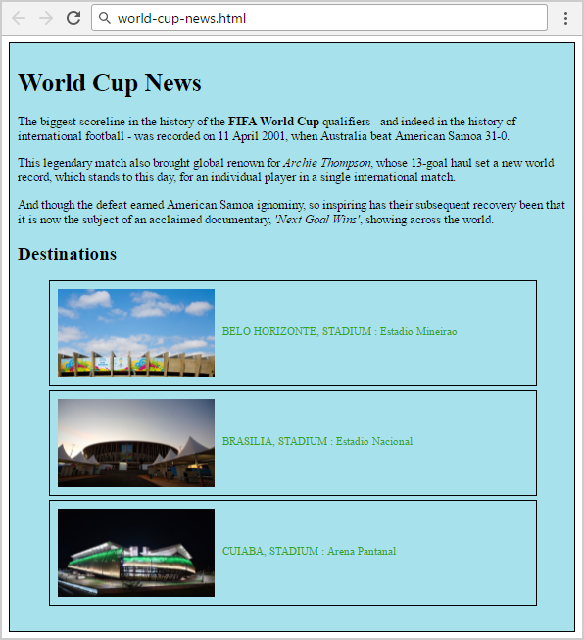

Create two files: “**world-cup-news.html**” and “**world-cup-news.css**”

### Constraints

* **<div>** with **id=** **"wrapper"** as a **container**
  + Width container: 700px;
  + Height container: 730px;
  + Border: 1px solid #000000;
  + Center the **container**
  + Padding**:** 10px;
  + Background Color: #a6e1ec;
* <h1>and<h2>tags for headings
* <p> tag for paragraph
* <strong>tag for **bold** text
* <em>tag for **italic** text
* <img> tag for images
  + Width: 200px;
  + Margin Right: 10px;
  + Vertical Align:middle;
* <span class= "text">for the text next to images
  + Text color: #2EA620;
* <li>tag
  + Width: 600px;
  + Padding: 10px;
  + Margin Bottom: 5px;
  + Font Size: 14px;
  + Border: 1px solid #000000;